网站修改：
- LOGO 后边添加以下内容：
Sinpco optoelectronic Co., Ltd
Professional LED indoor and outdoor lighting manufacturer and exporter

2, About us 添加二级类别
Company profile （Empresa） 公司简介
Factory tour (Fábrica fotos) 工厂图片
Certification (Certificación) 认证图片

- Contact us: (去掉这一句英文：Have a question……way we can)
Sinpco…. (直接写公司名)
Address:……
Tel:...
Fax:…
Zip:…
Website:…

Contact us 在联系方式下面加个询盘表格, 点击 Inquiry 链接到这个页面
询盘表格之前的文字描述改成：
At Sinpco, we would be glad to be of service to you. If you are interested in our LED Lighting products, please fill out the form below and include details in the comments field, we will contact you ASAP. The information you share with us will be kept highly confidential and will not be shared with outsiders.

- solutions 分Indoor lighting solutions , Outdoor lighting solutions
点击Solutions 页面类似下图：
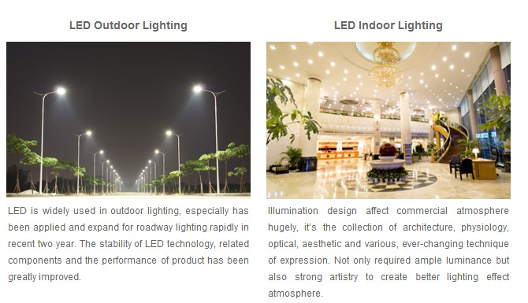
这一页面也跟 首页 Solutions 类似的链接
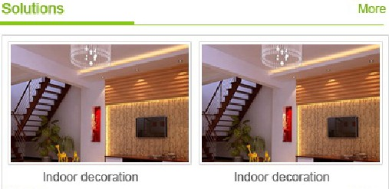
然后点击Indoor lighting solutions 或是 Outdoor lighting solutions 页面是：
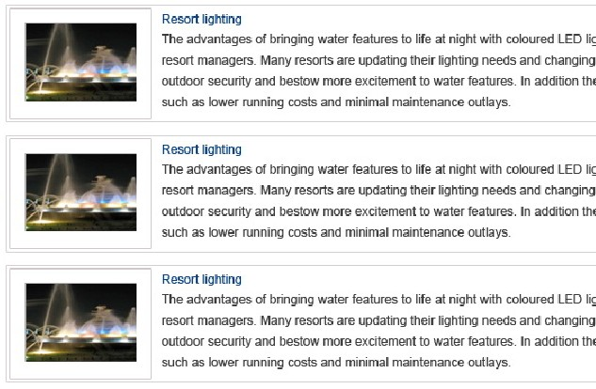
点击图片可以进入到详细页面，类似：
http://www.tellco-europe.com/billboard.html

- 产品页

- 产品图片有放大镜效果

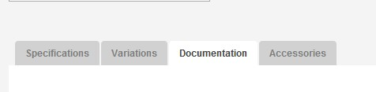
类似这样，但添加3个 ―― Specifications, features, Applications
5, 首页 Online service
Tel:
Fax:
Mobile:
MSN:
Skype:
Email:

6, 首页导航设置下拉菜单
About us 下拉菜单
Company profile
Factory tour
Certification

Products 下拉菜单
Indoor lighting Outdoor lighting
LED high bay LED floodlight LED tube
LED office light LED tunnel light,
LED panel light LED street light
LED down light
LED bulbs
LED spotlight

Solutions 下拉菜单
Indoor lighting
Outdoor lighting

